In day5 I focus mainly on understanding Cypress and write test cases for this

* Add to cart
  + describe('Cart Operations - Add Items by Product ID', () => {
  + beforeEach(() => {
  + // Navigate directly to the product details page using a hardcoded product ID
  + const productId = 'YjFIo1g1LQZHJZg27PUDNv'; // Replace with a valid product ID
  + cy.visit(`/product/${productId}`);
  + });
  + it('should add the product to the cart from the product details page', () => {
  + // Verify the product details are displayed
  + cy.get('[data-testid="product-title"]').should('exist'); // Replace with the actual product name
  + cy.get('[data-testid="product-price"]').should('exist');
  + // Add the product to the cart
  + cy.get('[data-testid="add-to-cart"]').click(); // Add the product to the cart
  + cy.get('[data-testid="cart-icon"]').click();
  + // Open the cart and verify the product is added
  + cy.get('[data-testid="cart-item"]').should('have.length', 1);
  + cy.get('[data-testid="cart-item"]').should('contain',); // Verify the correct product is added
  + });
  + });
* Update cart
  + describe('Cart Operations - Update Items', () => {
  + const productId = 'YjFIo1g1LQZHJZg27PUDNv'; // Replace with a valid product ID
  + beforeEach(() => {
  + // Navigate directly to the product details page using a hardcoded product ID
  + cy.visit(`/product/${productId}`);
  + cy.get('[data-testid="add-to-cart"]').click();
  + });
  + cy.get(`[data-testid="cart-item-${productId}"]`).within(() => {
  + cy.get('[data-testid="quantity-input"]').should('contain', '1'); // Check initial quantity
  + });
  + // Increase the quantity
  + cy.get(`[data-testid="cart-item-${productId}"]`).within(() => {
  + cy.get('[data-testid="quantity-increase"]').click(); // Click the + button
  + });
  + // Verify the updated quantity after increment
  + cy.get(`[data-testid="cart-item-${productId}"]`).within(() => {
  + cy.get('[data-testid="quantity-input"]').should('contain', '2'); // Verify quantity incremented
  + });
  + // Decrease the quantity
  + cy.get(`[data-testid="cart-item-${productId}"]`).within(() => {
  + cy.get('[data-testid="quantity-decrease"]').click(); // Click the - button
  + });
  + // Verify the updated quantity after decrement
  + cy.get(`[data-testid="cart-item-${productId}"]`).within(() => {
  + cy.get('[data-testid="quantity-input"]').should('contain', '1'); // Verify quantity decremented
  + });
  + // Ensure the quantity does not go below 1
  + cy.get(`[data-testid="cart-item-${productId}"]`).within(() => {
  + cy.get('[data-testid="quantity-decrease"]').click(); // Try to decrease below 1
  + cy.get('[data-testid="quantity-input"]').should('contain', '1'); // Verify it remains at 1
  + });
  + });
* Home page
  + Cypress code
    - describe("Navigation Tests", () => {
    - it("should load the homepage", () => {
    - // Visit the homepage
    - cy.visit("/");
    - // Verify that the URL is correct
    - cy.url().should("eq", "http://localhost:3000/");
    - // Check if a unique element like the logo, header, or navbar exists
    - });
    - it("should navigate to the About page", () => {
    - // Visit the homepage
    - cy.visit("/");
    - // Click on the About page link
    - cy.get('a[href="/about"]').click();
    - // Verify the URL has changed to /about
    - cy.url().should("include", "/about");
    - // Check if the About page has a unique element or identifier
    - });
    - });
* Dynamic Routing
  + - describe('Dynamic Routing Tests', () => {
    - const baseUrl = 'http://localhost:3000'; // Your app's base URL
    - const categoryId = '0e0ztuJY6NWdyblBES3JSp';
    - const productId = 'YjFIo1g1LQZHJZg27PUDNv';
    - it('should navigate to the category page with a dynamic ID', () => {
    - // Visit the category page
    - cy.visit(`${baseUrl}/category/${categoryId}`);
    - // Assert the correct category page loads
    - cy.url().should('include', `/category/${categoryId}`);
    - cy.get('h1').should('exist'); // Adjust to check for specific content, e.g., category name
    - });
    - it('should navigate to the product page with a dynamic ID', () => {
    - // Visit the product page
    - cy.visit(`${baseUrl}/product/${productId}`);
    - // Assert the correct product page loads
    - cy.url().should('include', `/product/${productId}`);
    - cy.get('h1').should('exist'); // Adjust to check for specific product title
    - });
    - });
* Product categories components
  + - describe('Product Categories Component', () => {
    - beforeEach(() => {
    - cy.visit('/'); // Navigate to the homepage where Products component is located
    - });
    - it('should display product categories with images', () => {
    - // Check if the "Top Categories" title is present
    - cy.get('h1').contains('Top Categories');
    - // Check if the slider is visible
    - cy.get('.slider-container').should('be.visible');
    - // Verify that categories are displayed with images
    - cy.get('[data-testid="product-category"]').should('have.length.greaterThan', 0); // Check for categories
    - // Check that each category has an image and a name
    - cy.get('[data-testid="product-category"]').each(($category) => {
    - cy.wrap($category).find('img').should('be.visible'); // Ensure image is present
    - cy.wrap($category).find('h3').should('not.be.empty'); // Ensure name is present
    - });
    - });
    - it('should navigate to category page when "Read More" is clicked', () => {
    - // Click on the "Read More" link for the first category
    - cy.get('[data-testid="product-category"]')
    - .first()
    - .find('a')
    - .click();
    - // Ensure the navigation leads to the correct category page
    - cy.url().should('include', '/category/');
    - });
    - });
* Search bar
  + - describe('Navbar Search Functionality', () => {
    - beforeEach(() => {
    - // Visit the page that contains the search functionality (replace with actual URL)
    - cy.visit('/'); // Replace with the actual URL where the search bar exists
    - });
    - it('should fetch and display products based on the search query', () => {
    - const searchQuery = 'chair'; // Define a sample search query
    - // Type into the search input field
    - cy.get('[data-testid="search-input"]').type(searchQuery); // Adjust selector for your search input field
    - // Click the search button to trigger the search
    - cy.get('[data-testid="search-button"]').click(); // Adjust selector for your search button
    - // Wait for the products to be fetched (add a wait or check network request if necessary)
    - cy.wait(500); // Optional: Add wait if there’s a delay in fetching results
    - // Verify that the products are displayed based on the search query
    - cy.get('[data-testid="search-result"]').each(($el) => {
    - // Verify that each result contains the search term
    - cy.wrap($el).should('contain.text', searchQuery);
    - });
    - // Optionally, verify that the search query is reflected in the results section (e.g., title or header)
    - cy.get('[data-testid="search-results-header"]').should('contain.text', `Results for "${searchQuery}"`);
    - });
    - it('should display a no results message when no products match the search query', () => {
    - const noResultsQuery = 'NonExistentProduct'; // Define a search query with no matching products
    - // Type into the search input field
    - cy.get('[data-testid="search-input"]').type(noResultsQuery);
    - // Click the search button
    - cy.get('[data-testid="search-button"]').click();
    - // Wait for results to be fetched
    - cy.wait(500);
    - // Verify that no products are displayed
    - cy.get('[data-testid="search-result"]').should('have.length', 0);
    - // Optionally, verify that a "no results" message is displayed
    - cy.get('[data-testid="no-results-message"]').should('be.visible').and('contain.text', 'No results found');
    - });
    - });

Postman

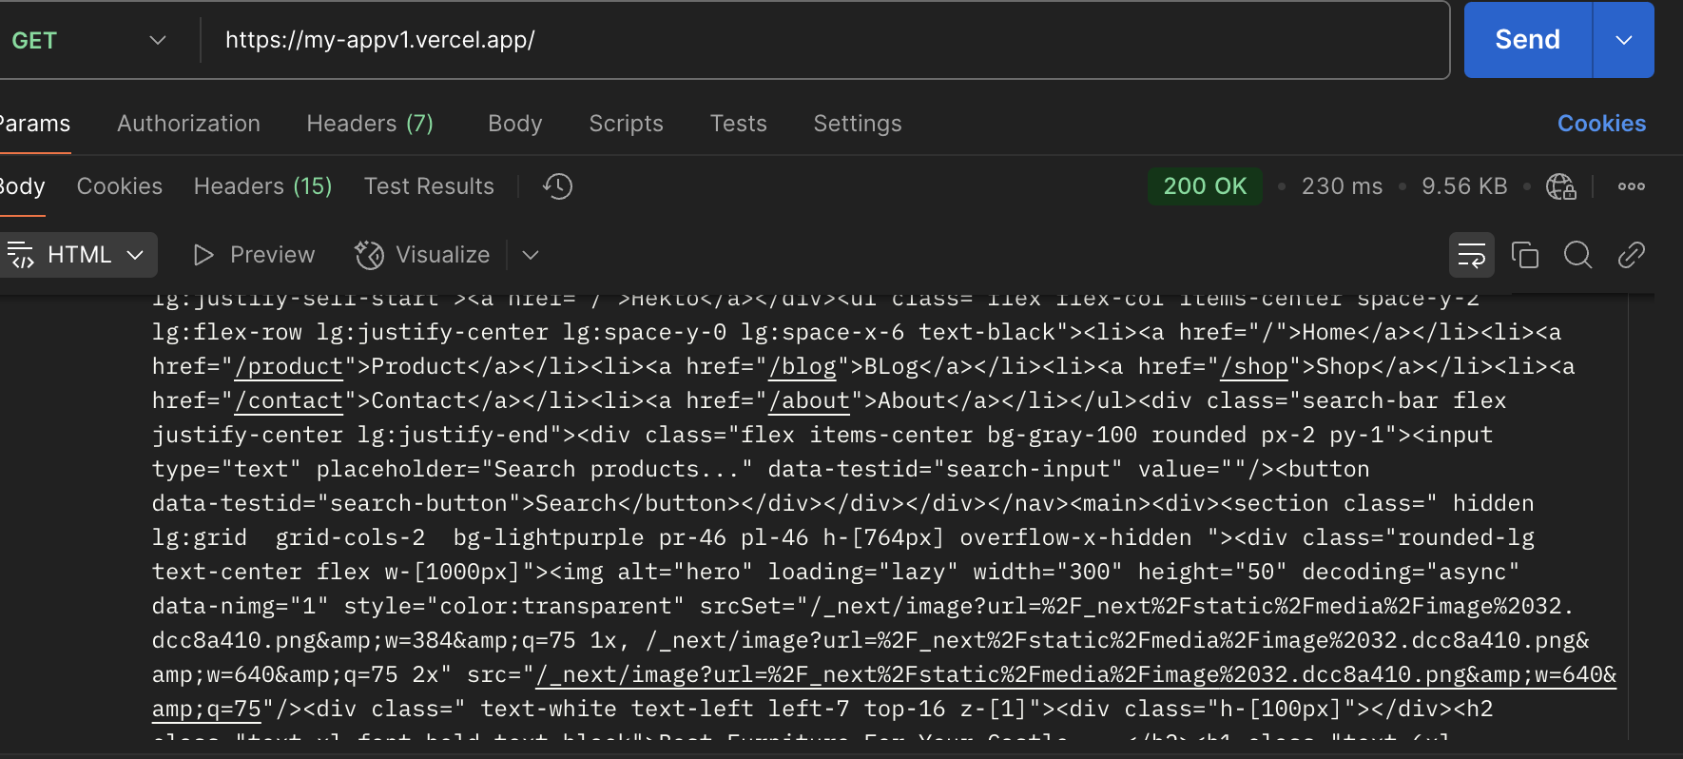

Performance checking

* 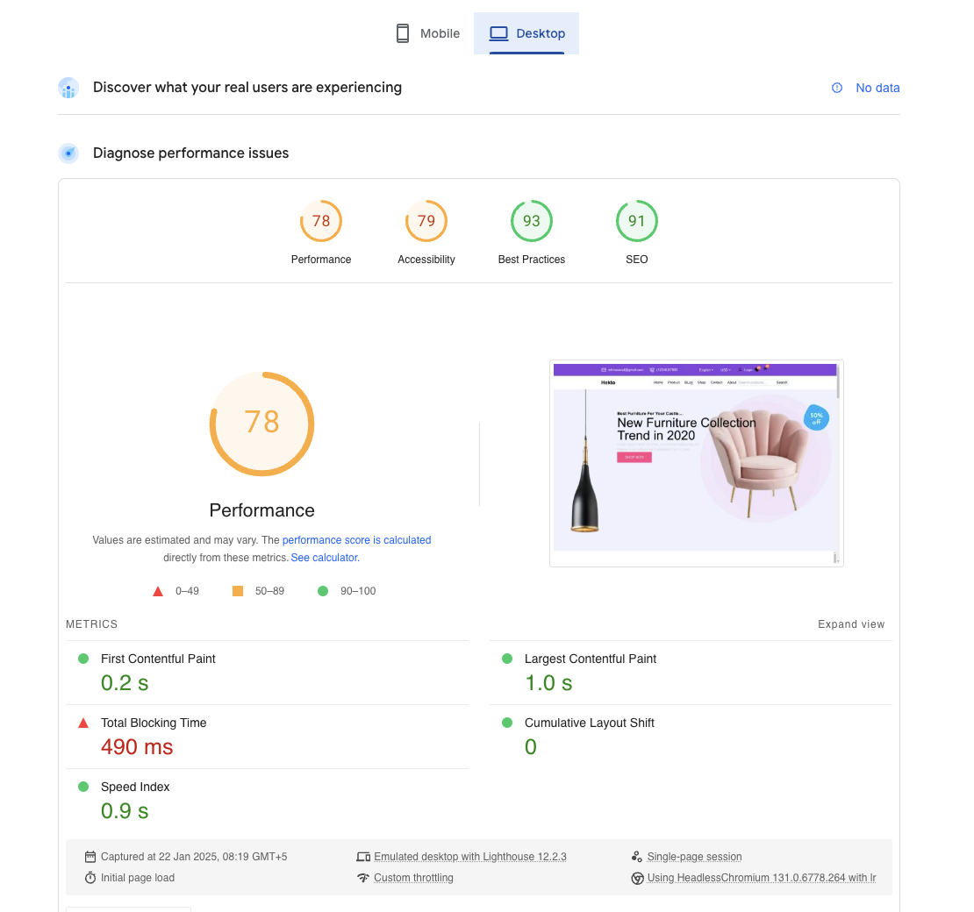

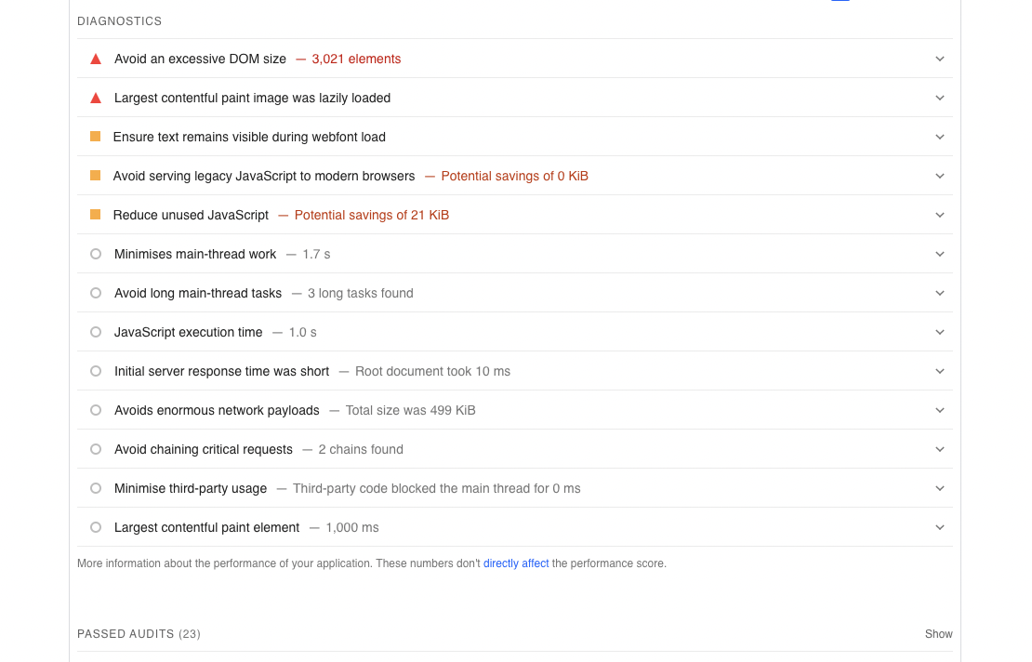

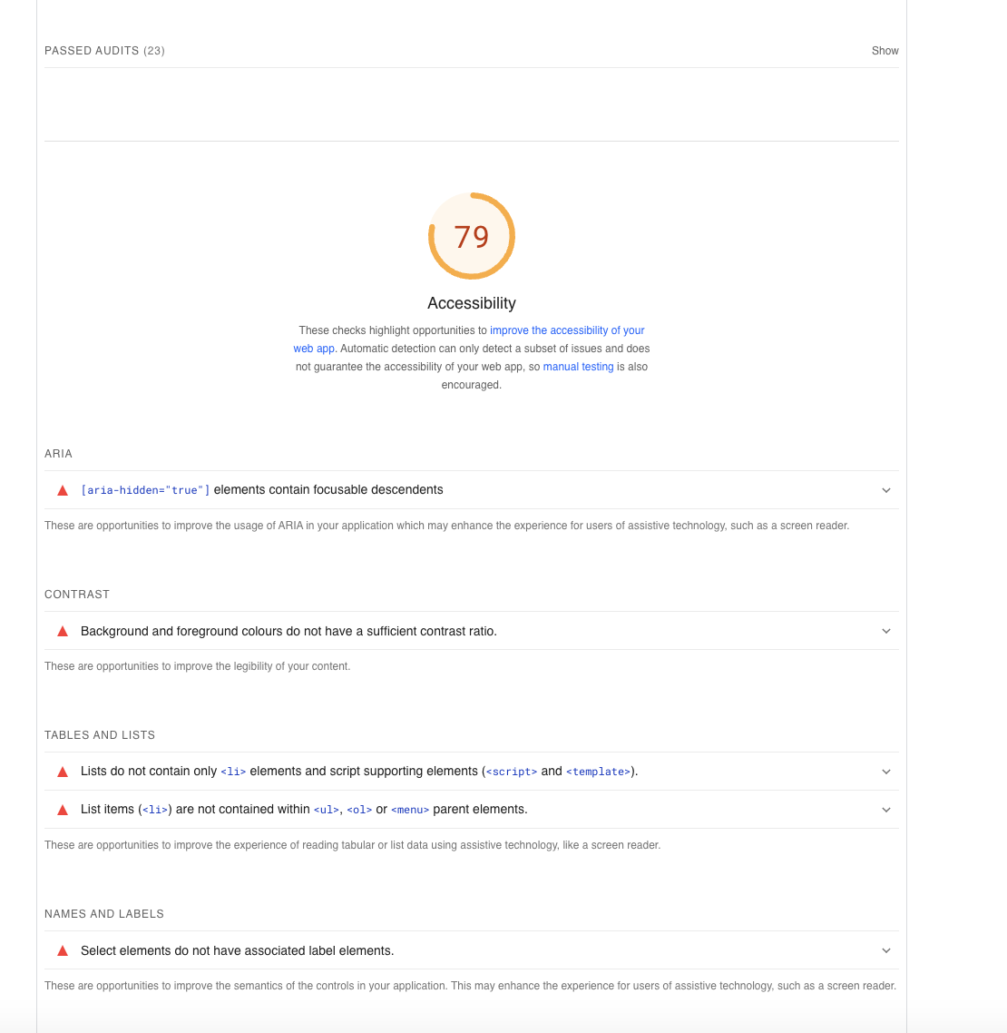

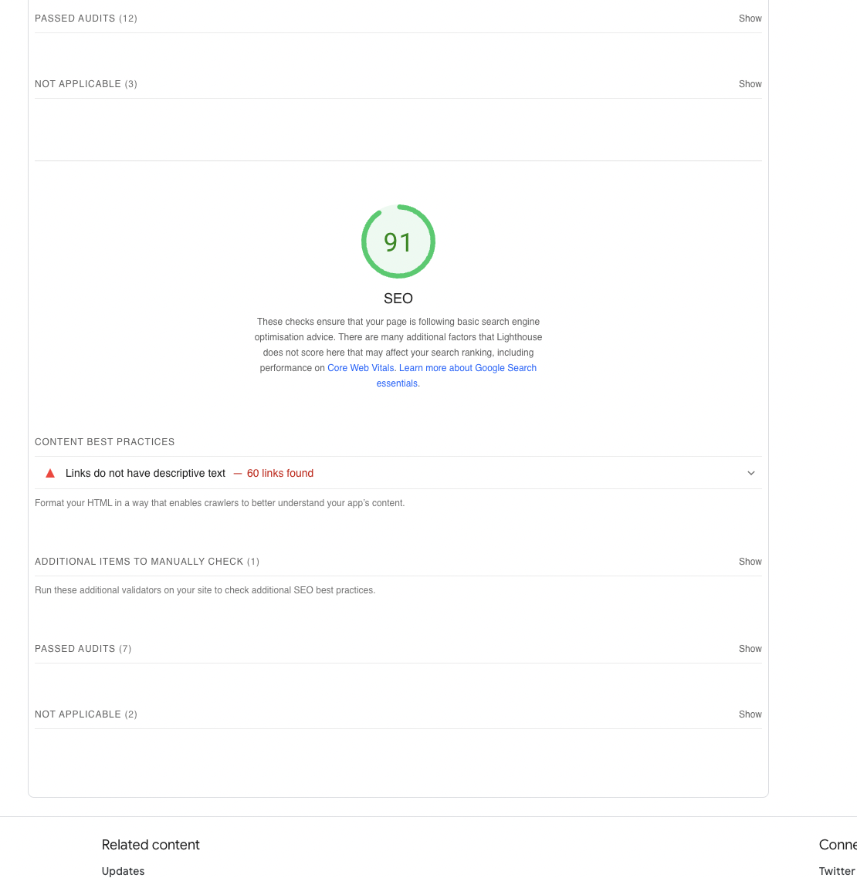

Error handling images

{c.image ? (

<Image

src={urlFor(c.image).url()} // Use category.image

alt={c.name || "Category Image"}

width={200}

height={200}

/>

) : (

<p>No image available</p>

)}

Error handling in product ->[id]->page.tsx

useEffect(() => {

const fetchProductData = async () => {

try {

const query = `*[_type == "product" && _id == $productId]{

_id,

name,

description,

price,

image,

category-> { _id, name }

}[0]`;

const data = await client.fetch(query, { productId: params.id });

setProduct(data);

} catch (err) {

setError("Failed to fetch product data");

} finally {

setIsLoading(false);

}

};

fetchProductData();

}, [params.id]);

Using burpesuit is paid so we have proxy 8080 and put the app in url that feature was disable for free version.

Cypress results

